

Oracle Cloud ERP Implementation Program | Phase 2

Integration Specifications

RICE ID | SCM-INT-1224
Interface Name | Create Purchase Orders - OTL
Project Stream | Procurement

Document Control Information
Document Information
Document Identification | SCM-INT-1224
Document Name | Create Purchase Orders - OTL
Project Name | Oracle Cloud ERP Implementation Program | Phase 2
Functional Owner | Deepak Verma
Technical Owner
Document Version
Date Released
Document Edit History
Version | Date | Additions/Modifications | Prepared/Revised by
1.0 | 25-Aug-26 | Initial Version | Deepak Verma
Document Review/Approval History
Date | Name | Organization/Title | Comments
Distribution of Final Document
The following people are designated recipients of the final version of this document:
Name | Organization/Title
Table of Contents
1 Integration Summary 4
1.1 Purpose/Justification 4
1.2 Integration Description and Overview 4
2 Functional Design 6
2.1 Integration Details 6
2.2. Data Selection and Sorting 6
2.3 Launch Parameters 7
2.4 Key Logic 7
2.5 Data Mapping 7
2.6 Data and Log File Layout 7
2.7 Archiving & Purging 7
2.8 Error Handling and Pre-Validation 7
2.9 Post Processing 7
2.10 Interface Restart/Rerun Requirements 8
2.11 Assumptions 8
2.12 Dependencies and Pre-requisites 8
2.13 Security 8
3 Technical Design 9
3.1 Overview 9
3.2 Integration Logic and Data Flow 9
3.3 Integration Tools 9
3.4 Middleware 9
3.5 Detailed Integration Design 9
3.5.1 <RICEID>_<Integration_Name> Integration Design 9
4 User Procedure and Test Scenarios 16
4.1 User Procedure 16
4.2 Unit Test Plan 16
5 Open and Closed Issues 17
5.1 Open Issues 17
5.2 Closed Issues 17

Integration Summary

1.1 Purpose/Justification
The objective of this integration to create Purchase order via interface using data from contingent workers time card. Once timecard is approved in OTL it will be interfaced to Oracle procurement to create Purchase Order.

1.2 Integration Description and Overview
This section provides a summary of the integration between OTL and Procurement. The integration aims to streamline data transfer and enhance operational efficiency across OTL and Procurement systems.

This integration details the process of creating Purchase Order in draft status using the time card details and agreement information captured at the contingent employee and submitting the purchase order for approval post creation. The approval will follow the requesters hierarchy based on the amount limit and job level.

Functional Design

2.1 Integration Details
Integration System Name | Create Purchase Order in Oracle Cloud
Integration Source | Oracle OTL
Integration Target | Oracle Procurement
Delivery or Retrieval Method | REST APIs
Full Extract / Changes Only | Once per transaction, no changes
Expected Volume | TBD
Run Frequency/Schedule | TBD
Integration Notifications | TBD

2.2. Data Selection and Sorting

Contingent worker will be submitting the timecard in OTL which will route for approval. Once approved, the data from the timecard is used to create a draft purchase order. The purchase order will be blanket purchase agreement (BPA) based and BPA information is expected to be captured/available at the worker level.

Once Purchase Order is created it will be submitted for approvals

2.3 Launch Parameters
The Interface will trigger everyday at.

2.4 Key Logic
This section details the logic to be used for building this interface between OTL and Procurement and Oracle subscription management cloud.
- Only approved timecard will be interfaced to oracle procurement to create purchase order
- Every timecard will be used to create new PO
- Supplier and Blanket purchase agreement details captured at contingent worker will be used for the purchase order to derive the price information
- The PO buyer will be same as agreement buyer
- Once Purchase order is created, interface should submit the PO and send for approval
- If BPA, supplier information and all 5 Projects details not available then provide the appropriate error message

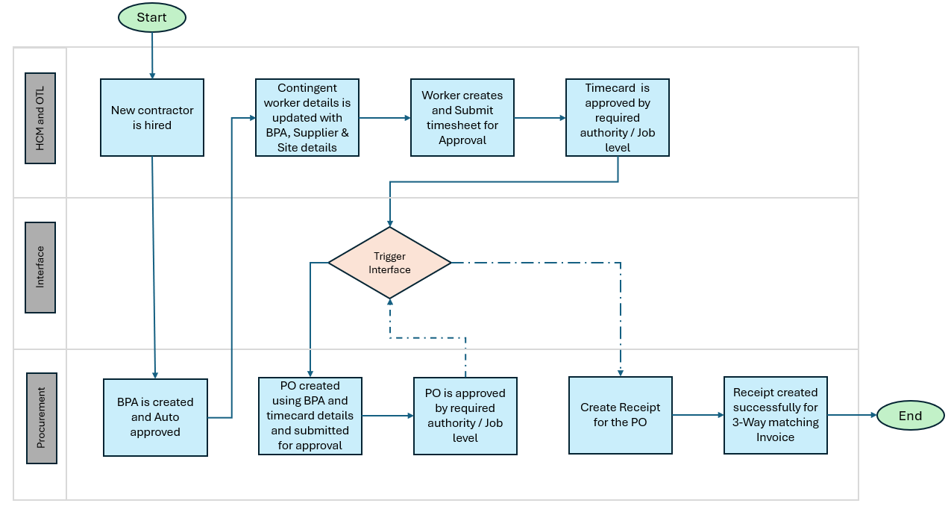

2.5 Data Mapping
Below is the data mapping for the PO PDF
Header Data
# | Field | Mapping
1 | Procurement BU | RBG SSC BU
2 | Requisition BU | LE BU - Legal Employer from Contingent worker
3 | Sold-to Legal Entity | Contingent Work Expense Account segment1
4 |  | Based on Country Canada or United Stated
  Bill-to BU
5 | Purchase Order # | PO Number auto generate
6 | Buyer | Same as BPA Buyer
7 | Supplier | Contingent worker EFF – Supplier Name
8 | Site | Contingent worker EFF – Supplier Site
9 | Ship to location | Burnaby for Canada, Lincoln for US
10 | Bill to location | Burnaby for Canada, Lincoln for US
11 | Description | Combination logic (Contractor name + Period from BPA + timecard hours)
12 | Agreement | Contingent worker EFF – BPA Number
13 | Source | Attribute 1 – Default to OTL
Line Data
Below are the PO line details mapping to PO creation.
# | Field | Mapping
1 | Line | Line number sequential
2 | Ship to | Same as Header
3 | Line Type | Rate Based Services
4 | Line description | Combination logic (Contractor name+position + Period from BPA + timecard hours)
5 | Unit of Measure | HR
6 | Purchasing Category | External/Temp Labor
7 | QTY | Timcard hours
8 | Price | Price from BPA
9 | Amount | Qty * price
10 | Required date | Creation date + 1 day
11 | Requester | Contingent worker who submitted the timecard
12 | Project Number | From Timecard
13 | Task Number | From timecard
14 | Expenditure Organization | From timecard
15 | Expenditure Item Date | End date from time card
16 | Expenditure Type | From timecard
17 | Charge Account | TBD (Make sure the segment 1 is same as employee expense account segment1)
18 | Invoice Match Option | Order
19 | Invoice Match Approval Level | 3 Way
20 | Accrue at Receipt | Yes

2.6 Data and Log File Output
Log file to be generated for all the interface runs

2.7 Archiving & Purging
Not applicable.

2.8 Error Handling and Pre-Validation
- Any errors generated during the processing of the PO a notification should be send out to oracle_program@rbauction.com
- The notification should include the reason for the error/ failure along with the transaction details
- The error should include the Timecard number, Worker name, Date and Line number if applicable

2.9 Post Processing
Not Applicable

2.10 Interface Restart/Rerun Requirements
Not Applicable

2.11 Assumptions
Below are the assumptions for PO creation process
- Only approved timecard will be interfaced to oracle procurement to create purchase order
- Every timecard will be used to create new PO
- Supplier and Blanket purchase agreement details captured at contingent worker will be used for the purchase order to derive the price information
- The PO buyer will be same as agreement buyer
- Once Purchase order is created, interface should submit the PO and send for approval
- Timecard should always have projects information mentioned in the data mapping section 2.5
- Buyer would be same as BPA buyer

2.12 Dependencies and Pre-requisites
Below are dependencies for the Interface.
- BPA, Supplier and Site to be available at Contingent worker
- Timecard should have project details and in approved status

2.13 Security
Procurement Agent is required by the user running the Interface.

Technical Design

3.1 Overview

3.2 Integration Logic and Data Flow

3.3 Integration Tools

3.4 Middleware

3.5 Detailed Integration Design

3.6 Integration Design
Integration Design
Integration System Name
Integration Type | Inbound  Outbound
Integration Tool | FBDI Template  BIP <Specify report name>  HDL <Specify template name>  Web Services <specify WSDL URL with specific operation, type (SOAP/REST)>  HCM Extract <Specify details in following sections>
Data Source (check all that apply) | Custom Report <insert report name>  Cloud Connect Template Type <specify CCW/PICOF/Other>  Web Service <insert WWS name or external web service>  File Inbound into Oracle <insert file name>
Delivery / Retrieval Service
Output/Inbound Filename
File Format
Sequence Generators
Document Retention
Integration System User
Integration System Security Group
Additional Information

Enterprise Scheduler Services (ESS) Job details
<Provide the ESS JOB name details>
Program | Short Name | Application | Description

Enterprise Scheduler Services (ESS) Parameters
<Provide the ESS JOB parameters>

Program Name | Parameter Name | Value | Comment

Inbound Integration Specific Details
<Needed in Case on Inbound Integrations>
Integration Details
Entity Names | - Provide the HDL or PBL entity/entities which are getting loaded
Integration Attributes | - List of attributes
Integration Maps | - <list if applicable>
Validation | - <list if applicable>
Sample File/Payload | - <attach input file/payload in case of service based>
Defaulting Logic | <List of any attributes whose values are defaulted >
Additional Logic | Add any additional logic specific to the interface
Deployment Details | Details of Deployment (PaaS or Client Network)
Database Details | Database connection details for the program

BI Reports
- Report 1
Data Model Name | Location

<Mention the SQL queries used in the data model>
Report SQL Queries (Insert SQL Queries)

<Mention the parameter names used in the data model>
Parameter Name | Data Type | Default Value | LOV Query

<Mention the details of the Template>
Report Name | Template Name | Layout Name | Output Format

<Mention the details of the layout>
Report Layout (Attach RTF Template)

- Report 2
<Mention the details of the Data Model along with the Catalog Location>
Data Model Name | Location

<Mention the SQL queries used in the data model>
Report SQL Queries (Insert SQL Queries)

<Mention the parameter names used in the data model>
Parameter Name | Data Type | Default Value | LOV Query

<Mention the details of the Template>
Report Name | Template Name | Layout Name | Output Format

<Mention the details of the layout>
Report Layout (Attach RTF Template)

OIC Details

Integration Details

- Integration 1
Integration Name
Description
Package Name
List of Connections | Connection Name | Connection Type

- Integration 2
Integration Name
Description
Package Name
List of Connections | Connection Name | Connection Type

- Lookups
Name
Description

Name
Description

<Adapter/Domain Name> | <Adapter/Domain Name>

OIC Process Flow

OIC Common Services Details
<Insert common service details used by this interface>

Custom Database Objects

Table
Following Custom objects will be created for the Interface:
Table Name | Owner | Purpose
Column Name | Data Type | Size | Comments

View
View Name | Schema | Additional Details
Indexes
Index Name | Index on Table | Additional Details
Sequence
Sequence Name | Sequence on Table | Additional Details
Package
Package Name | Additional Details
Function
Function Name | Additional Details

Procedure
Procedure Name | Additional Details

Triggering/Starting Event(s) for the interface.
<Describe the details as to when/what initiate the triggers>
Trigger Name | Module Name | Listener | Comments

Components list
Component Name | Component Type | Purpose

Installation/Migration steps
TBD

Exception and Error Handling

Error and Messages Processing

Code | Description | System | Owner | Corrective Action

Log Output

Restart Strategy
Failure Scenario | Restart Strategy

User Procedure and Test Scenarios

4.1 User Procedure

4.2 Unit Test Plan

S. No | Test Scenarios | Expected Result
1 | Create PO using interface | Verify all the PO information’s
2 | Submit the PO for approval | PO should be in pending approval status post creation from Interface
3 | Verify the accounting entries | Check the accounting is generated correctly based on project information needed

Open and Closed Issues

5.1 Open Issues
<Describe open issues here that could affect the Interface design>
Date Reported | Opened By | Description | Comments | Due Date | Responsible

5.2 Closed Issues
<List the closed issues here>
Date Reported | Description | Resolution | Due Date | Closed Date | Sign off

About Deloitte
As used in this communication, ‘Deloitte’ means Deloitte Touche Tohmatsu Limited and its member firms.
Deloitte refers to one or more of Deloitte Touche Tohmatsu Limited, a UK private company limited by guarantee (“DTTL”), its network of member firms, and their related entities. DTTL and each of its member firms are legally separate and independent entities. DTTL (also referred to as “Deloitte Global”) does not provide services to clients. Please see www.deloitte.com/about for a more detailed description of DTTL and its member firms.
Deloitte provides audit, consulting, financial advisory, risk management, tax and related services to public and private clients spanning multiple industries. With a globally connected network of member firms in more than 150 countries and territories, Deloitte brings world-class capabilities and high-quality service to clients, delivering the insights they need to address their most complex business challenges. Deloitte’s more than 220,000 professionals are committed to making an impact that matters.

External Communications Disclaimer
This communication contains general information only, and none of Deloitte Touche Tohmatsu Limited, its member firms, or their related entities (collectively, the “Deloitte Network”) is, by means of this communication, rendering professional advice or services. Before making any decision or taking any action that may affect your finances or your business, you should consult a qualified professional adviser. No entity in the Deloitte Network shall be responsible for any loss whatsoever sustained by any person who relies on this communication.
Internal Communications Disclaimer
This communication is for internal distribution and use only among personnel of Deloitte Touche Tohmatsu Limited, its member firms, and their related entities (collectively, the “Deloitte Network”). None of the Deloitte Network shall be responsible for any loss whatsoever sustained by any person who relies on this communication.
© 2017, For Information contact Deloitte Touche Tohmatsu.

